

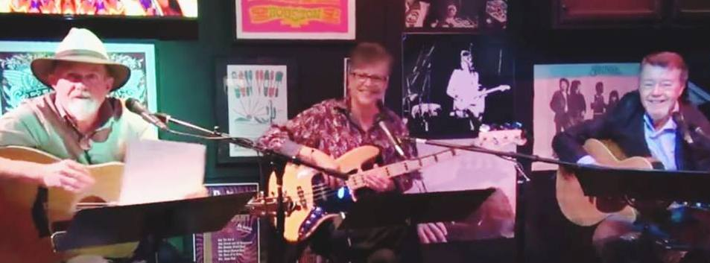

**60’s to Contemporary**

**Pop and Americana**

 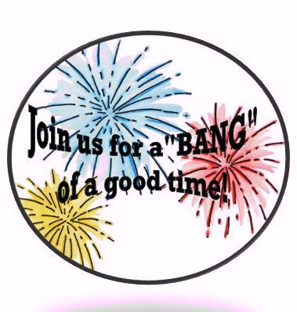

**1030 Heights Blvd**

**July 4th, 2019**

**6:30 PM – 8:30 PM**